References
Including terms and definitions

Version 0.1
Sidst opdateret: 2022-09-08, Karsten K Nielsen

The references list is established ad hoc (for purpose), and hence is not a systematic mapping of most essential subject matter experts. The list is updated on update-on-awareness-basis, and may therefore not be updated with the latest info on persons, organisations ect. It will however be updated whenever I get aware of any obsolete information.

The information in this list is based on publically available or acquired information; hence, no private information has been disclosed

As the list may be useful to other people than me, I have decided to share the list.

Contents
1. Names/persons 3
2. Institutions, associations & think tanks 4
3. Serious media outlets 9
4. Reports & legislation 9
5. Other features, literature, podcasts, social media, broadcasts etc. 11
6. Databases guides towards consumption based data 12
7. Other references with relation to climate change 14
8. Terms and definitions 14

Table of tables
Table 1: Names/persons 3
Table 2: Institutions, associations & think tanks 4
Table 3: Serious media outlets 9
Table 4: Reports & legislation 9
Table 5: Other features, literature, podcasts, social media, broadcasts etc. 11
Table 5: Databases or guides towards consumption based data 12
Table 6: Other references with relation to climate change 14
Table 7: Terms and definitions 14

Names/persons
Table 1: Names/persons
Navne
Navne | Organisation |  | Kommentarer/Link
Christian Ibsen | CONCITO | Direktør
Eigil Kaas. | KU | Professor  Is-, Klima- og Geofysik  videnskabelig leder af Nationalt Center for Klimaforskning hos DMI | Refererede udtalser (ej citat):  - Mange fokuserer på det nationale CO2-regnskab. Men det vigtige er, som jeg ser det, hvor meget CO2-udledning vi i alt gør os ansvarlige for, også når vi køber varer ude i verden,  - at tankegangen er for snæver, når politikere og andre udråber Danmark som klimaduks.  - Men det er, fordi mange ikke ønsker at medregne vores samlede klimaaftryk inklusiv vores forbrug, siger han
Harpa Birgisdottir | AU | Byggeri, Aalborg Universitet  https://vbn.aau.dk/da/persons/121001/projects/
Jens Hjarsbech | Axcelfuture | Seniorøkonom  Axcelfuture (erhvervlivest tænketank)  Jens Uhrskov Hjarsbech – Chief Economist – Axcelfuture | DANMARKS CO2-AFTRYK ER STØRRE END  UDLEDNINGEN – OG STAMMER MEST FRA UDLANDET:  https://static1.squarespace.com/static/5c8265907d0c91092007f8cf/t/5e28566406f0a742d33a28d9/1579701863349/Danmarks+CO2-aftryk+er+st%C3%B8rre+end+udledningen.pdf
Kirsten Halsnæs |  | Professor, DTU  Professor i klima og økonomi på DTU
Michael Minter |  | Programchef i Concito
Sebastian H. Mernild |  | Sebastian Haugaard Mernild er en dansk ph.d. og dr.scient, der siden 2020 har været prorektor ved Syddansk Universitet. Desuden er han professor i klimaforandringer og glaciologi. | Flere udtalelser for TV2:  https://vejr.tv2.dk/2020-12-07-15-graders-maalet-er-helt-urealistisk-viser-ny-klima-analyse
Sofie Winge-Petersen | Ungeklimarådet | https://kefm.dk/klima-og-vejr/ungeklimaraadet
Thomas Meinert |  | https://www.klimabevaegelsen.dk/om-os
Prof. Eliot Jacobson |  |  | Twitter bio: Retired professor of mathematics and computer science, now a full time husband, volunteer and grandfather. Know-it-all doomer & planet walker, b. 316 ppm
Prof. Stefan Rahmstorf |  | Head of Earth System Analysis at Potsdam Institute for Climate Impact Research | Twitter bio: Head of Earth System Analysis at Potsdam Institute for Climate Impact Research; professor of Physics of the Oceans at Potsdam University; dad. Opinions my own!

Institutions, associations & think tanks
Table 2: Institutions, associations & think tanks
Institutioner
Navn | Kilde |  | Kommentarer/Link
Concito |  | https://concito.dk/ | Danmarks Grønne Tænketank
Klimabevægelsen DK |  | https://www.klimabevaegelsen.dk/
Klimarådet |  | https://klimaraadet.dk/
Energistyrelsen |  | http://www.ens.dk | Særligt: Design og produktion: Energistyrelsen  Særligt: kap2.: Danmarks forbrugsbaserede  Klimaaftryk  God indgang til klimaloven:  https://ens.dk/ansvarsomraader/energi-klimapolitik/fakta-om-dansk-energi-klimapolitik/dansk-klimapolitik
Klima, energi og forsyningsministeriet |  | https://kefm.dk
Det eropæiske råd  Rådet for den eropæiske union |  | https://www.consilium.europa.eu/da/ | https://www.consilium.europa.eu/da/infographics/paris-agreement-eu/  https://www.consilium.europa.eu/da/policies/climate-change/paris-agreement/
Danmarks Statistik |  |  | Eksempelvis:  Emissionsregnskab  https://www.dst.dk/da/Statistik/dokumentation/statistikdokumentation/emissionsregnskab  Klimaloven/CO2 reduction:  https://www.dst.dk/da/Statistik/temaer/klima  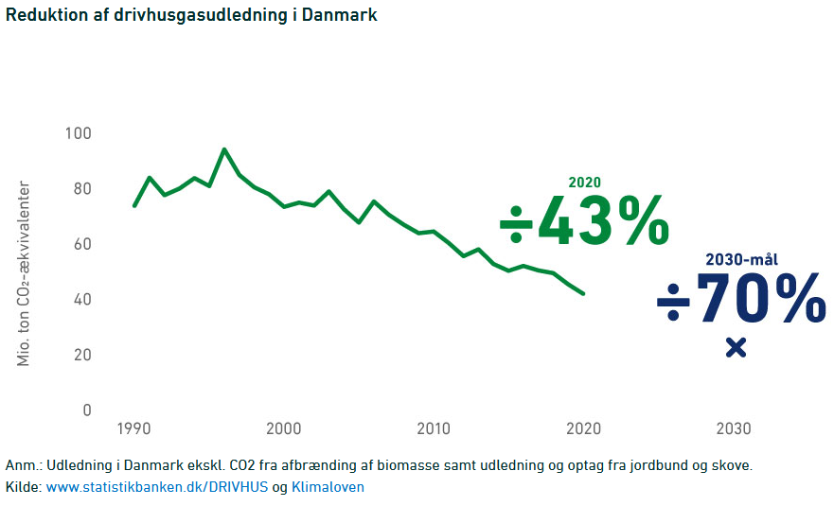  https://www.dst.dk/da/Statistik/nyheder-analyser-publ/Analyser/visanalyse?cid=47752  Data gennem årene:  https://www.statistikbanken.dk/DRIVHUS
Eropean Environment agency |  | https://www.eea.europa.eu/ | https://www.eea.europa.eu/data-and-maps/data/data-viewers/greenhouse-gases-viewer  DK emmisioner I 1990 co2e: 79,766 mio ton (inkl. Internal aviation)  Danmarks Statistik: 83 mio tons (ekskl. Biogas afbrænding)  Danmarks udledning af CO2 -  indsatsen i perioden 1990-2001 og  omkostningerne herved, Miljøministeriet, hoverapport (Det Energipolitiske Udvalg  EPU alm. del - Bilag 53  O, Redegørelse fra Miljøstyrelsen Nr. 2 2005)  Angiver : 69,5 mio ton Co2e som ” basis” tabel 3,2 p.32 i https://www.ft.dk/samling/20042/almdel/EPU/bilag/53/155996.pdf  DST, Erhvervshåndbogen Klimaledese:  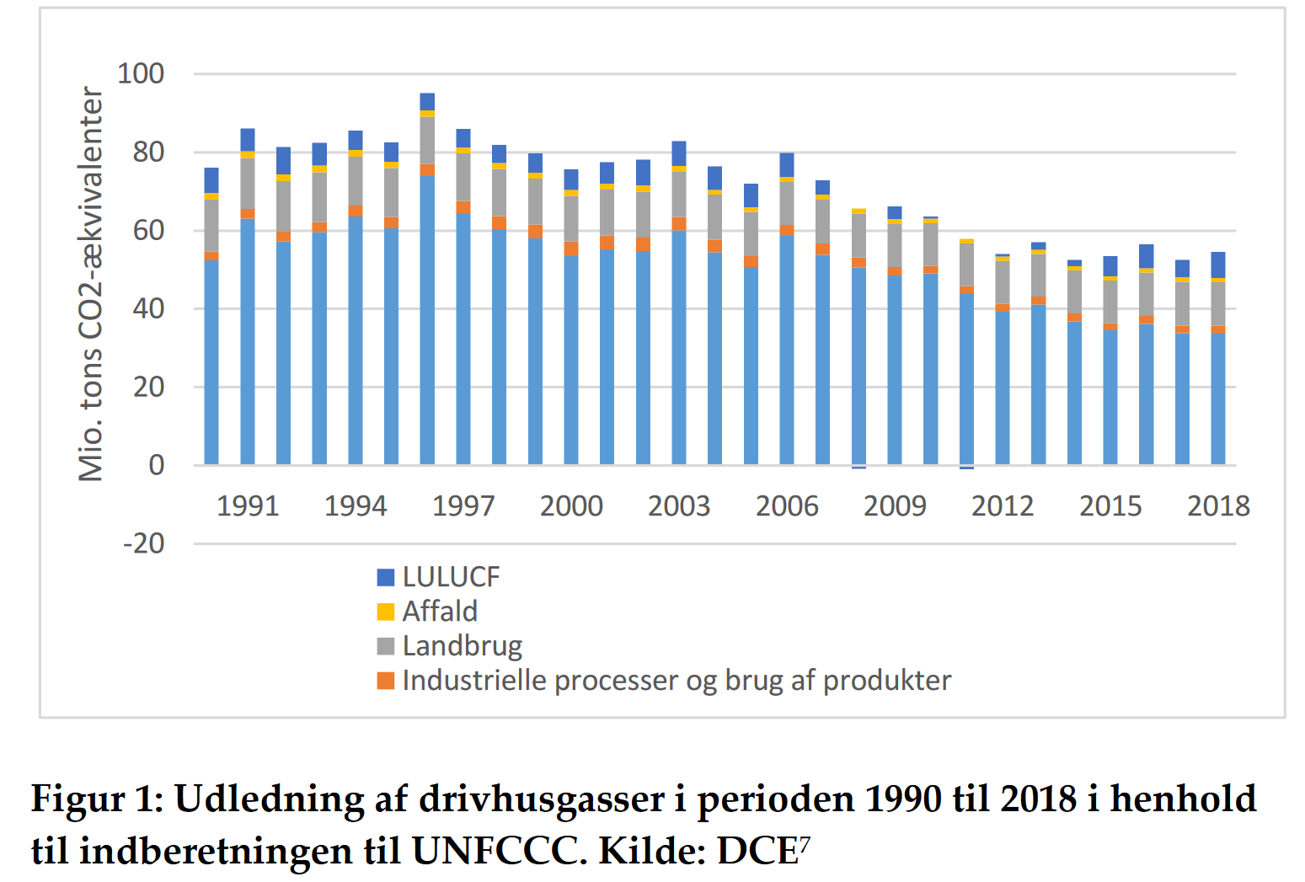  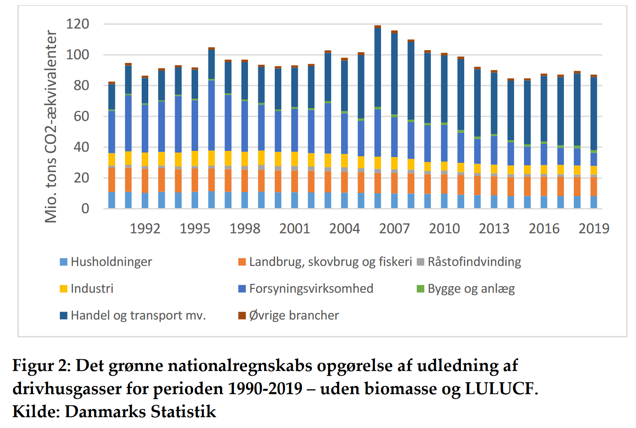
Københavns Universitet | KU | Københavns Universitet  Det Samfundsvidenskabelige Fakultet  https://samf.ku.dk  Anders Blok  Institut for Antroprologi  Telefon: +45 35 32 78 77  Mail: H.Samuelsen@anthro.ku.dk | Danmarks mål om 70 pct. reduktion i 2030 er ikke en retfærdig fordeling af ansvaret, 16. marts 2022:  https://samf.ku.dk/presse/kronikker-og-debat/2022/danmarks-maal-om-70-pct.-reduktion-i-2030-er-ikke-en-retfaerdig-fordeling-af-ansvaret/
Our World in data |  | https://ourworldindata.org/co2-emissions | God youtube video – intro til CO2:  https://www.youtube.com/watch?v=ipVxxxqwBQw  https://ourworldindata.org/grapher/annual-co-emissions-by-region  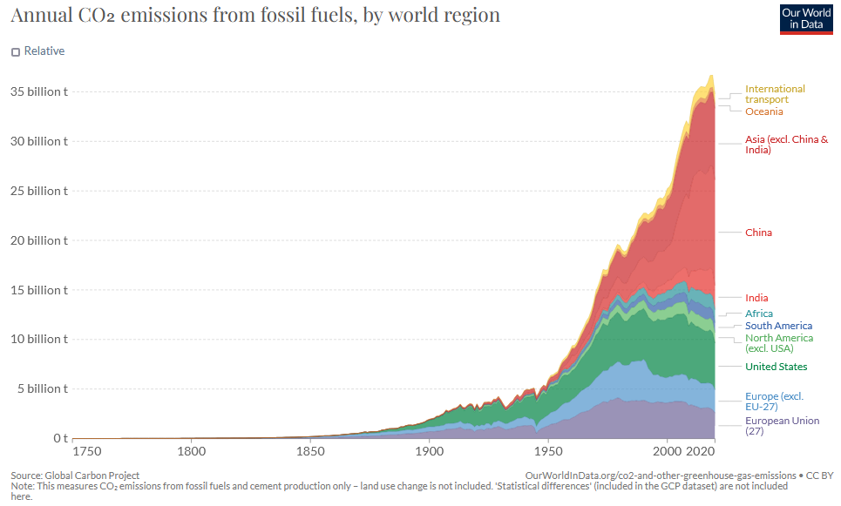  Refererer til denne kilde: https://www.icos-cp.eu/science-and-impact/global-carbon-budget/2021
Worldmrio |  | https://worldmrio.com/footprints/carbon/ | DATA fra hele verden indtil 2018
Aarhus Universitet  Institut for Miljøvidenskab |  | https://envs.au.dk
Eionet  Central Data Repository |  | https://cdr.eionet.europa.eu/dk/ | https://cdr.eionet.europa.eu/dk/Air_Emission_Inventories
Miljøbevægelsen NOAH |  | NOAHs klimasider  https://global-klima.org/ | Om 1,5 gradersmålsætningen  https://global-klima.org
IPCC |  | The Intergovernmental Panel on Climate Change  https://www.ipcc.ch/ | Downloads under ‘Menu’
Transport & Environment |  | https://www.transportenvironment.org/challenges/planes/
EU Emissions Trading System (EU ETS) |  | https://ec.europa.eu/clima/eu-action/eu-emissions-trading-system-eu-ets_en

Serious media outlets
Table 3: Serious media outlets
Titel | Kilde |  | Kommentarer/Link
TV2 |  |  | 1,5 graders-målet er helt urealistisk, viser ny klima-analyse (2020):  https://vejr.tv2.dk/2020-12-07-15-graders-maalet-er-helt-urealistisk-viser-ny-klima-analyse
Guardian
Politiken
Ingeiøren |  |  | Aviation:  https://ing.dk/artikel/flytrafik-udleder-rekordmeget-co2-stiger-26-pct-paa-fem-aar-225151

Reports & legislation
Table 4: Reports & legislation
Ref ID | Navne | Kilde |  | Kommentarer/Link
 | 3 grad mehr |  | https://www.youtube.com/watch?v=MlpOq31Cf3Q | Klaus Wiegandt
 | Global  Afrapportering  2022 |  | Design og produktion: Energistyrelsen https://ens.dk/sites/ens.dk/files/Analyser/ga22_-_hovedrapport.pdf  http://www.ens.dk
 | ga22_-_hovedrapport.pdf
 | Klimaloven, LOV nr 965 af 26/06/2020 |  | https://www.retsinformation.dk/eli/lta/2020/965 | Se visning fra Danmark Statistik: https://www.dst.dk/da/Statistik/temaer/klima
 | Climate Change 2021  The Physical Science Basis | IPCC | https://www.ipcc.ch/report/ar6/wg1/downloads/report/IPCC_AR6_WGI_Full_Report.pdf
 | Første officielle vurdering af Danmarks globale klimaaftryk | KEMP, April 2021 | https://kefm.dk/aktuelt/nyheder/2021/apr/foerste-officielle-vurdering-af-danmarks-globale-klimaaftryk | Se også flere delrapporter + faktaark
 | Global afrapportering 2022 | ENS | https://ens.dk/service/fremskrivninger-analyser-modeller/global-afrapportering-2022 | Linket af ovenstående KEMP hjemmeside  Flere klider og tal på denne side
 | Videnskab.dk |  |  | Kina mindsker andre landes CO2-aftryk:  https://videnskab.dk/naturvidenskab/kina-mindsker-andre-landes-co2-aftryk
 | DST Analyse - Dansk forbrug sætter i høj grad sit klimaaftryk i udlandet, 2021 |  |  | https://www.dst.dk/Site/Dst/Udgivelser/nyt/GetAnalyse.aspx?cid=47752

Other features, literature, podcasts, social media, broadcasts etc.
Table 5: Other features, literature, podcasts, social media, broadcasts etc.
Artilker | Artilker
Ref ID | Titel | Kilde |  | Kommentarer/Link
 | Fremlæggelser
 | 3-grad mehr fremlæggelse |  | https://www.youtube.com/watch?v=MlpOq31Cf3Q | Klaus Wiegandt
 | Første officielle vurdering af Danmarks globale klimaaftryk |  | https://kefm.dk/aktuelt/nyheder/2021/apr/foerste-officielle-vurdering-af-danmarks-globale-klimaaftryk | Sammenfatning af rapporten: ga22_-_hovedrapport.pdf
 | DKK |  | Deutsches Klima Konsordium | https://www.deutsches-klima-konsortium.de/de/basisfakten.html
 | Online medier
 | Klimamonitor |  | https://klimamonitor.dk/om/  Filip Knaack Kirkegaard
 | Energiwatch |  | https://energiwatch.dk/  Redaktør: Maz Plechinger
 | Greenmatch |  | https://www.greenmatch.dk
 | Web site content
 | Gør noget grønt: Forlæng levetiden på dit køkken og alt andet | Bolius | https://www.bolius.dk/goer-noget-groent-forlaeng-levetiden-paa-dit-koekken-og-alt-andet-94966 | Om køkkeners levetid
 | Rapport: ”Større trivsel med mindre klimabelastning” | Consito | https://concito.dk/sites/concito.dk/files/u60/stoerre_trivsel_med_mindre_klimabelastning_livsstilskatalog_020117.pdf | 2017  Forfattere: Mikael Bellers Madsen og Simon Elsborg Nygaard
 | Her er de nedslående konklusioner i FN's klimarapport | TV2, aug 2021 | https://nyheder.tv2.dk/klima/2021-08-09-her-er-de-nedslaaende-konklusioner-i-fns-klimarapport
 | Tre tipping points | TV2, aug 2021 | https://nyheder.tv2.dk/klima/2021-08-09-her-er-tre-laviner-for-klimaet-der-giver-forskere-hovedpine
 | Shipping | Zetland | Danmarks klimaregnskab ser egentlig ret godt ud. Men vi vælger så også at se bort fra én temmelig stor post (zetland.dk) | Om mangler i Klimaloven: https://www.zetland.dk/historie/sekdkM29-aOMNamWw-1ba95  Af Mads Nyvold og Thomas Hebsgaard
 | https://worldmrio.com |  |  | https://worldmrio.com/footprints/carbon/

Databases guides towards consumption based data
Table 5: Databases or guides towards consumption based data
 | Rapporter
 | Navne | Kilde |  | Kommentarer/Link
 | Databaser
 | Generelt
[601] | Den store klimadatabase - baggrundsrapport | CONCITO | https://concito.dk/udgivelser/store-klimadatabase-baggrundsrapport | Den store klimadatabase giver virksomheder, myndigheder og borgere fri adgang til livscyklusanalyser af klimabelastningen fra 500 af de mest almindelige fødevarer og drikkevarer. Baggrunden for projektet, beregningsmetoder, resultater, anvendelsesmuligheder og -vejledning er beskrevet i denne baggrundsrapport.
 | madvarer
 | Liste over andre fødevaredatabaser | [601] | Eksisterende fødevarelister og databaser Der findes allerede en række danske og internationale fødevarelister og databaser, som samler klimaaftryk for fødevarer fra forskellige studier:  • Mogensen et al. (2016): Tabel over fødevarers klimaaftryk  • Röös (2014): Mat-Klimat-listan  • Unilevers CO2-beregner (Unilever Food Solutions): Dækker ca. 100 varer baseret på beregninger fra WSP baseret på forskellige LCA-undersøgelser og rapporter  • Mindful FOOD Solutions (Henrik Saxe): Datasamling solgt på licens til KU, Professionshøjskolen, beregning af Coops madpyramide mv.  • RISE klimatdatabas (RISE Research Institutes of Sweden): Svensk database med 750 fødevarer. Kræver licens.  • Poore et al. (2018): Artikel om miljødata for fødevarer publiceret i Science  • Moberg et al. (2019): Samling af LCA-studier på ca. 100 varer.  • Agribalyse (ADEME, 2019): Database med miljøindikatorer for 2.500 fødevarer produceret og forbrugt i Frankrig.
 | Så stort er dit CO2-aftryk | Greenmatch, 20?? | https://www.greenmatch.dk/blog/2016/05/saa-stort-er-dit-co2-aftryk | Med tal fra: Kilde: CONCITO (2021): Den store klimadatabase, version 1
 | madvarer
klimaberegner |  |  | https://ve.dk/klimaberegner/ | OK, men med betydelige mangler

Other references with relation to climate change
Table 6: Other references with relation to climate change
Artilker
Titel | Kilde |  | Kommentarer/Link

Terms and definitions
Table 7: Terms and definitions
Artilker
Term | Definition | Comments or reference
Scope 1, 2 and 3 carbon emissions | Scope 1, 2 and 3 is a way of categorising the different kinds of carbon emissions a company creates in its own operations, and in its wider value chain.  Definitions of scope 1, 2 and 3 emissions  Essentially, scope 1 and 2 are those emissions that are owned or controlled by a company, whereas scope 3 emissions are a consequence of the activities of the company but occur from sources not owned or controlled by it.  Scope 1 emissions  Scope 1 covers emissions from sources that an organisation owns or controls directly – for example from burning fuel in our fleet of vehicles (if they’re not electrically-powered).  Scope 2 emissions  Scope 2 are emissions that a company causes indirectly when the energy it purchases and uses is produced. For example, for our electric fleet vehicles the emissions from the generation of the electricity they're powered by would fall into this category.  Scope 3 emissions  Scope 3 encompasses emissions that are not produced by the company itself, and not the result of activities from assets owned or controlled by them, but by those that it’s indirectly responsible for, up and down its value chain. An example of this is when we buy, use and dispose of products from suppliers. Scope 3 emissions include all sources not within the scope 1 and 2 boundaries. | https://www.nationalgrid.com/stories/energy-explained/what-are-scope-1-2-3-carbon-emissions  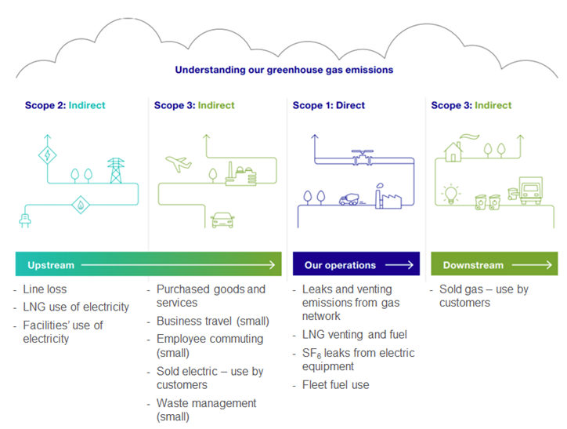
Scope 1, 2 and 3 carbon emissions | Greenhouse gas emissions are categorised into three groups or 'Scopes' by the most widely-used international accounting tool, the Greenhouse Gas (GHG) Protocol. Scope 1 covers direct emissions from owned or controlled sources. Scope 2 covers indirect emissions from the generation of purchased electricity, steam, heating and cooling consumed by the reporting company. Scope 3 includes all other indirect emissions that occur in a company’s value chain  Scope 1:  Fuel combustion  Company vehicles  Fugitive emissions  Scope 2:  Purchased electricity, heat and steam  Scope 3:  Purchased goods and services  Business travel  Employee commuting  Waste disposal  Use of sold products  Transportation and distribution (up- and downstream)  Investments  Leased assets and franchises | https://www.carbontrust.com/resources/briefing-what-are-scope-3-emissions
Consumption-based accounting (CBA) of emissions | Also called carbon footprints.  Accounts for emissions associated with imported and exported goods. CBA reports the total emissions associated with final demand in each country  Scope 1 emissions— This one covers the Green House Gas (GHG) emissions that a company makes directly — for example while running its boilers and vehicles.  Scope 2 emissions — These are the emissions it makes indirectly – like when the electricity or energy it buys for heating and cooling buildings, is being produced on its behalf.  Scope 3 emissions — Now here’s where it gets tricky. In this category go all the emissions associated, not with the company itself, but that the organisation is indirectly responsible for, up and down its value chain. For example, from buying products from its suppliers, and from its products when customers use them. Emissions-wise, Scope 3 is nearly always the big one. | https://www2.deloitte.com/uk/en/focus/climate-change/zero-in-on-scope-1-2-and-3-emissions.html
Det danske klimaaftryk | Det danske klimaaftryk er de udledninger, som skabes af dansk forbrug og anden endelig anvendelse – uanset om udledningerne sker i Danmark eller i andre lande via import af varer til Danmark. Udledninger fra produktion til dansk eksport medregnes til gengæld ikke. Klimaaftrykket viser, hvordan dansk forbrug bidrager til den globale udledning af drivhusgasser. Danmarks Statistik opgør det danske klimaaftryk som eksperimentel statistic | https://www.dst.dk/da/Statistik/temaer/klima
Udledning fra dansk økonomi, inkl. danske transportvirksomheder i udlandet | Udledning fra dansk økonomi, inkl. danske transportvirksomheder i udlandet indeholder ud over udledningerne i Danmark også udledning fra international transport, herunder især udledninger fra danskopererede skibes brug af olie, der bunkres (tankes) i udlandet. Opgørelsen gør det muligt at analysere sammenhængen mellem forskellige økonomiske aktiviteter og påvirkninger af miljø og klima. | https://www.dst.dk/da/Statistik/temaer/klima
Territorial emissions | Emissions physically occurring in a country  Sometimes called production-based accounting (PBA). This is the standard reporting of GHG emissions as reported by CDIAC, IEA, the JRC EDGAR database, UNFCCC, and others. | https://worldmrio.com/footprints/carbon/  Emissions from fossil fuel combustion and cement production are reattributed to the countries where final demand induced the production associated with those emissions. Emissions from aviation and marine bunker fuels are not included in the CBA inventory, as no method has yet been developed to allocate emissions from bunker fuels to countries other than where the fuel is bunkered.induced the production associated with those emissions. Emissions from aviation and marine bunker fuels are not included in the CBA inventory, as no method has yet been developed to allocate emissions from bunker fuels to countries other than where the fuel is bunkered.
Udledning i Danmark | Udledning i Danmark bliver brugt til at følge udviklingen i forhold til internationale klimamålsætninger, fx indberetning til FN og forpligtigelserne i Parisaftalen og Danmarks egne målsætninger i Klimaloven. | https://www.dst.dk/da/Statistik/temaer/klima

